FRATERNITIE,
SORORITIE,
BRASSERIE.
Nous sommes grecs

Greekfest
Brew Pub Tour
For those who are not paddlers (that’s hazing, you know), join us for a tour of several local brew pubs!
The price for this day of libation covers transportation to five area brew pubs
(lunch and beer purchases not included):
Depart Indian Head Campground at 10:15am on Saturday, June 24.
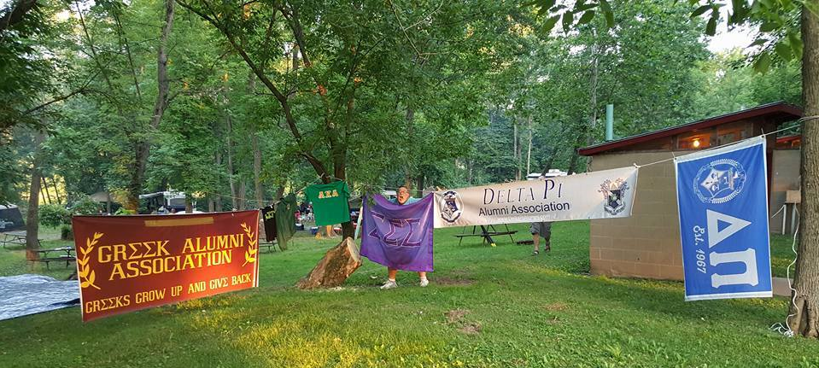

First stop: Rusty Rail Brewing Company, Mifflinburg
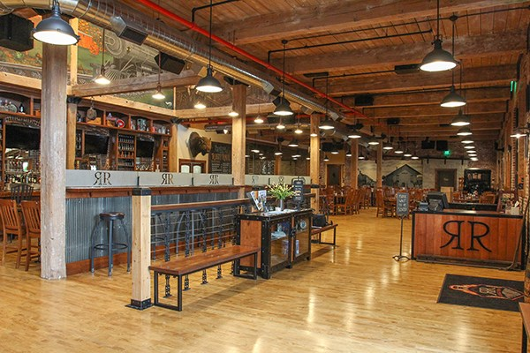

Second stop: Selin's Grove Brewing Company, Selingsgrove
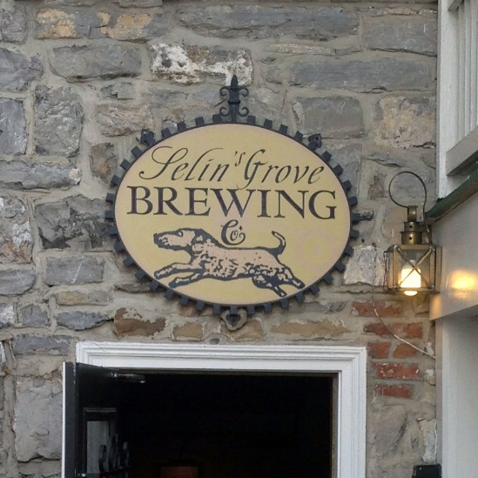

Third Stop: Old Forge Brewing Company, Danville
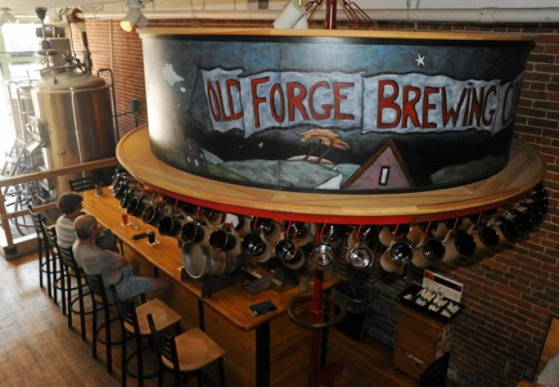

Fourth Stop: Turkey Hill Brewing Company, Bloomsburg
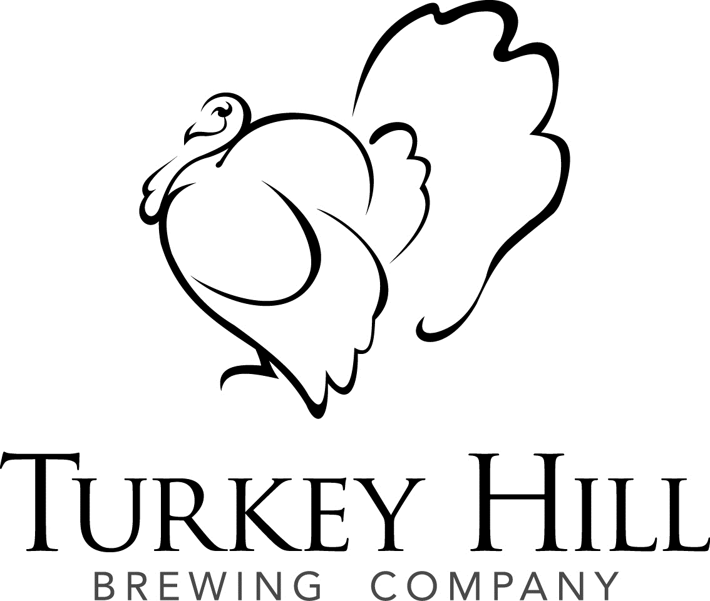
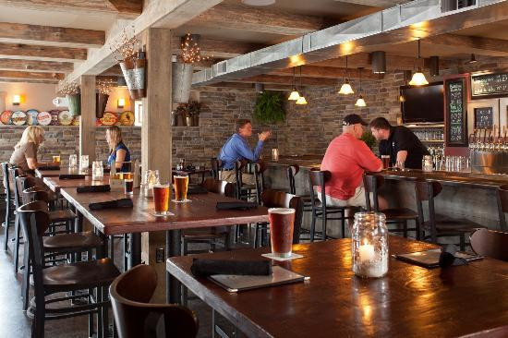

Final Stop: Berwick Brewing Company, Berwick
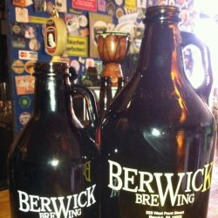

Return to Indian Head Campground at 6:15pm- in time for dinner!
